**Experiment No 4**

**Aim:** Design / create website using Bootstrap including Grid system, Forms, Button, Navbar, Breadcrumb, Jumbotron.

**Code:**

**(Index.html)**

**HTML code**

<html>

<head>

  <title>

    Website Using Bootstrap

  </title>

<link rel="stylesheet" href="style.css">

<link rel="stylesheet"

href="https://cdn.jsdelivr.net/npm/bootstrap@5.1.1/dist/css/bootstrap.min.css">

<!-- JavaScript Bundle with Popper -->

<script src="https://cdn.jsdelivr.net/npm/bootstrap@5.1.1/dist/js/bootstrap.bundle.min.js" integrity="sha384-/bQdsTh/da6pkI1MST/rWKFNjaCP5gBSY4sEBT38Q/9RBh9AH40zEOg7Hlq2THRZ" crossorigin="anonymous"></script>

<link rel="stylesheet" href="https://cdn.jsdelivr.net/npm/@fortawesome/fontawesome-free@5.15.4/css/fontawesome.min.css">

</head>

<body>

<section id="nav-bar">

  <nav class="navbar navbar-expand-lg navbar-light bg-light">

    <div class="container-fluid">

      <a class="navbar-brand" href="#"> <img src="img/logo.png" width="10%"></a>

      <button class="navbar-toggler" type="button" data-bs-toggle="collapse" data-bs-target="#navbarNav" aria-controls="navbarNav" aria-expanded="false" aria-label="Toggle navigation">

        <span class="navbar-toggler-icon"></span>

      </button>

      <div class="collapse navbar-collapse" id="navbarNav">

        <ul class="navbar-nav ml-auto">

          <li class="nav-item">

            <a class="nav-link " href="index.html">Home</a>

          </li>

          <li class="nav-item">

            <a class="nav-link" href="library.html">Library</a>

          </li>

          <li class="nav-item">

            <a class="nav-link" href="contact.html">Contact</a>

          </li>

          <li class="nav-item">

            <a class="nav-link" href="about.html">About</a>

          </li>

        </ul>

      </div>

    </div>

  </nav>

</section>

<section class="container2">

  <p>First Name <input type="text" name="" id="" placeholder="First Name"></p>

  <p>Last Name <input type="text" name="" id="" placeholder="Last Name"></p>

  <p>Mobile Number <input type="number" name="" id="" placeholder="Mobile Number"></p>

  <div class="btn-group">

  <button type="button" class="btn btn-success">Submit</button>

  </div>

</section>

<section>

  <nav aria-label="breadcrumb">

    <ol class="breadcrumb">

      <li class="breadcrumb-item active" aria-current="page">Home</li>

    </ol>

  </nav>

  <nav aria-label="breadcrumb">

    <ol class="breadcrumb">

      <li class="breadcrumb-item"><a href="index.html">Home</a></li>

      <li class="breadcrumb-item active" aria-current="page">Library</li>

    </ol>

  </nav>

  <nav aria-label="breadcrumb">

    <ol class="breadcrumb">

      <li class="breadcrumb-item"><a href="index.html">Home</a></li>

      <li class="breadcrumb-item"><a href="library.html">Library</a></li>

      <li class="breadcrumb-item"><a href="contact.html"></a>Contact</li>

    </ol>

  </nav>

  <nav aria-label="breadcrumb">

    <ol class="breadcrumb">

      <li class="breadcrumb-item"><a href="index.html">Home</a></li>

      <li class="breadcrumb-item"><a href="library.html">Library</a></li>

      <li class="breadcrumb-item"><a href="contact.html"></a>Contact</li>

      <li class="breadcrumb-item active" aria-current="page">About</li>

    </ol>

  </nav>

</section>

<section>

  <button type="button" class="btn btn-primary">Primary</button>

  <button type="button" class="btn btn-secondary">Secondary</button>

  <button type="button" class="btn btn-success">Success</button>

  <button type="button" class="btn btn-danger">Danger</button>

  <button type="button" class="btn btn-warning">Warning</button>

  <button type="button" class="btn btn-info">Info</button>

  <button type="button" class="btn btn-light">Light</button>

  <button type="button" class="btn btn-dark">Dark</button>

</section>

</body>

</html>

**(Library.html)**

HTML

<html>

<head>

  <title>

    Website Using Bootstrap

  </title>

<link rel="stylesheet" href="style.css">

<link rel="stylesheet"

href="https://cdn.jsdelivr.net/npm/bootstrap@5.1.1/dist/css/bootstrap.min.css">

<!-- JavaScript Bundle with Popper -->

<script src="https://cdn.jsdelivr.net/npm/bootstrap@5.1.1/dist/js/bootstrap.bundle.min.js" integrity="sha384-/bQdsTh/da6pkI1MST/rWKFNjaCP5gBSY4sEBT38Q/9RBh9AH40zEOg7Hlq2THRZ" crossorigin="anonymous"></script>

<link rel="stylesheet" href="https://cdn.jsdelivr.net/npm/@fortawesome/fontawesome-free@5.15.4/css/fontawesome.min.css">

</head>

<body>

<section id="nav-bar">

  <nav class="navbar navbar-expand-lg navbar-light bg-light">

    <div class="container-fluid">

      <a class="navbar-brand" href="img/logo.png"><img src="img/logo.png" width="10%"></a>

      <button class="navbar-toggler" type="button" data-bs-toggle="collapse" data-bs-target="#navbarNav" aria-controls="navbarNav" aria-expanded="false" aria-label="Toggle navigation">

        <span class="navbar-toggler-icon"></span>

      </button>

      <div class="collapse navbar-collapse" id="navbarNav">

        <ul class="navbar-nav">

          <li class="nav-item">

            <a class="nav-link " href="index.html">Home</a>

          </li>

          <li class="nav-item">

            <a class="nav-link" href="library.html">Library</a>

          </li>

          <li class="nav-item">

            <a class="nav-link" href="contact.html">Contact</a>

          </li>

          <li class="nav-item">

            <a class="nav-link" href="about.html">About</a>

          </li>

        </ul>

      </div>

    </div>

  </nav>

</section>

<section>

    <span>

        <h3>Library</h3>

    </span>

    <div class="jumbotron container contain">

      <h1 class="display-4" >Hello, world!</h1>

      <p class="lead">This is a simple hero unit, a simple jumbotronstyle component for calling extra attention to featured content or information.</p>

      <hr class="my-4">

      <p>It uses utility classes for typography and spacing to space content out within the larger container.</p>

      <a class="btn btn-primary btn-lg" href="#" role="button">Learn more</a>

    </div>

</section>

</body>

</html>

**(Contact.html)**

**HTML**

<html>

<head>

  <title>

    Website Using Bootstrap

  </title>

<link rel="stylesheet" href="style.css">

<link rel="stylesheet"

href="https://cdn.jsdelivr.net/npm/bootstrap@5.1.1/dist/css/bootstrap.min.css">

<!-- JavaScript Bundle with Popper -->

<script src="https://cdn.jsdelivr.net/npm/bootstrap@5.1.1/dist/js/bootstrap.bundle.min.js" integrity="sha384-/bQdsTh/da6pkI1MST/rWKFNjaCP5gBSY4sEBT38Q/9RBh9AH40zEOg7Hlq2THRZ" crossorigin="anonymous"></script>

<link rel="stylesheet" href="https://cdn.jsdelivr.net/npm/@fortawesome/fontawesome-free@5.15.4/css/fontawesome.min.css">

<link href="https://fonts.googleapis.com/css2?family=Poppins:ital,wght@0,100;0,200;0,300;0,400;0,500;0,600;1,100;1,400;1,500&display=swap" rel="stylesheet">

<link rel="stylesheet" href="https://maxcdn.bootstrapcdn.com/font-awesome/4.7.0/css/font-awesome.min.css">

</head>

<body>

<section id="nav-bar">

  <nav class="navbar navbar-expand-lg navbar-light bg-light">

    <div class="container-fluid">

      <a class="navbar-brand" href="img/logo.png"><img src="img/logo.png" width="10%"></a>

      <button class="navbar-toggler" type="button" data-bs-toggle="collapse" data-bs-target="#navbarNav" aria-controls="navbarNav" aria-expanded="false" aria-label="Toggle navigation">

        <span class="navbar-toggler-icon"></span>

      </button>

      <div class="collapse navbar-collapse" id="navbarNav">

        <ul class="navbar-nav">

          <li class="nav-item">

            <a class="nav-link " href="index.html">Home</a>

          </li>

          <li class="nav-item">

            <a class="nav-link" href="library.html">Library</a>

          </li>

          <li class="nav-item">

            <a class="nav-link" href="contact.html">Contact</a>

          </li>

          <li class="nav-item">

            <a class="nav-link" href="about.html">About</a>

          </li>

        </ul>

      </div>

    </div>

  </nav>

</section>

<span>

    <h3>Contact</h3>

</span>

<section class="location">

    <iframe src="https://www.google.com/maps/embed?pb=!1m18!1m12!1m3!1d3771.420338346257!2d72.83949831412316!3d19.045247957889323!2m3!1f0!2f0!3f0!3m2!1i1024!2i768!4f13.1!3m3!1m2!1s0x3be7c92fb093d785%3A0x38854a716f0ca945!2sXavier%20Institute%20of%20Engineering!5e0!3m2!1sen!2sin!4v1628659881087!5m2!1sen!2sin" width="600" height="450" style="border:0;" allowfullscreen="" loading="lazy"></iframe>

</section>

<section class="contact-us">

    <div class="row">

        <div class="contact-col">

            <div>

                <i class="fa fa-home"></i>

                <span>

                    <h5>

                        Opposite S.L.Raheja Hospital, Mahim Causeway, Mahim (West), Raheja Hospital Marg, Mumbai, Maharashtra 400016

                    </h5>

                </span>

            </div>

            <div>

                <i class="fa fa-phone"></i>

                <span>

                    <h5>

                        +912224455937

                    </h5>

                    <p>Monday to Friday, 7:30AM to 6PM</p>

                </span>

            </div>

            <div>

                <i class="fa fa-envelope-o"></i>

                <span>

                    <h5>

                        info@xie.com

                    </h5>

                    <p>Email us your Query</p>

                </span>

            </div>

        </div>

        <div class="contact-col">

            <form action="">

                <input type="text" placeholder="Enter your name" required>

                <input type="Email" placeholder="Enter your Email" required>

                <input type="text" placeholder="Enter your Subject" required>

                <textarea rows="8" placeholder="Message" required></textarea>

                <button type="submit" class="hero-btn blue-btn">Send Message</button>

            </form>

        </div>

    </div>

</section>

</body>

</html>

**(About.html)**

**HTML**

<html>

<head>

  <title>

    Website Using Bootstrap

  </title>

<link rel="stylesheet" href="style.css">

<link rel="stylesheet"

href="https://cdn.jsdelivr.net/npm/bootstrap@5.1.1/dist/css/bootstrap.min.css">

<!-- JavaScript Bundle with Popper -->

<script src="https://cdn.jsdelivr.net/npm/bootstrap@5.1.1/dist/js/bootstrap.bundle.min.js" integrity="sha384-/bQdsTh/da6pkI1MST/rWKFNjaCP5gBSY4sEBT38Q/9RBh9AH40zEOg7Hlq2THRZ" crossorigin="anonymous"></script>

<link rel="stylesheet" href="https://cdn.jsdelivr.net/npm/@fortawesome/fontawesome-free@5.15.4/css/fontawesome.min.css">

<!--Footer bundle-->

<link href="https://fonts.googleapis.com/css2?family=Poppins:ital,wght@0,100;0,200;0,300;0,400;0,500;0,600;1,100;1,400;1,500&display=swap" rel="stylesheet">

<link rel="stylesheet" href="https://maxcdn.bootstrapcdn.com/font-awesome/4.7.0/css/font-awesome.min.css">

</head>

<body>

<section id="nav-bar">

  <nav class="navbar navbar-expand-lg navbar-light bg-light">

    <div class="container-fluid">

      <a class="navbar-brand" href="img/logo.png"><img src="img/logo.png" width="10%"></a>

      <button class="navbar-toggler" type="button" data-bs-toggle="collapse" data-bs-target="#navbarNav" aria-controls="navbarNav" aria-expanded="false" aria-label="Toggle navigation">

        <span class="navbar-toggler-icon"></span>

      </button>

      <div class="collapse navbar-collapse" id="navbarNav">

        <ul class="navbar-nav">

          <li class="nav-item">

            <a class="nav-link " href="index.html">Home</a>

          </li>

          <li class="nav-item">

            <a class="nav-link" href="library.html">Library</a>

          </li>

          <li class="nav-item">

            <a class="nav-link" href="contact.html">Contact</a>

          </li>

          <li class="nav-item">

            <a class="nav-link" href="about.html">About</a>

          </li>

        </ul>

      </div>

    </div>

  </nav>

</section>

<section class="footer">

    <h4>

        About Us

    </h4>

    <p>Lorem ipsum dolor sit amet consectetur adipisicing elit. Ut hic dignissimos corporis et magnam. Dicta!

    </p>

    <div class="icons">

        <i class="fa fa-facebook"></i>

        <i class="fa fa-twitter"></i>

        <i class="fa fa-instagram"></i>

    </div>

    <p>

        Made with <i class="fa fa-heart-o"></i> by @Sandeep Sahani

    </p>

</section>

</body>

</html>

**(CSS Code)**

*

{

    margin: 0;

    padding: 0;

}

body

{

    font-family: sans-serif;

}

#nav-bar

{

    position: sticky;

    top: 0;

    z-index: 10;

}

.navbar

{

    background-image: linear-gradient(to right, blue,rgb(108, 16, 255));

}

.navbar-nav li

{

    padding: 0% 10px;

}

.navbar-nav li a

{

    color: white;

    font-weight: 600;

}

#jumbotron

{

    padding-bottom: 0%;

    margin: auto;

}

span h3

{

    border-radius: 6px;

    padding: 10px;

    background-color: #5a22f7;

    margin:10px 500px;

    text-align: center;

}

.container2{

    margin: 10px 20%;

    background-color:rgb(18, 89, 243);

    border-radius:6px;

    padding: 10px;

    color: rgb(106, 191, 248);

    }

    input[type="text"],

    input[type="number"]{

    margin: 5px 0px;

    padding: 10px;

    border:none;

    border-radius: 3px;

    width: 100%;

}

Button

{

    position: static;

}

.footer

{

    width: 100%;

    text-align: center;

    padding: 30px 0;

}

.footer h4

{

    margin-bottom: 25px;

    margin-top: 20px;

    font-weight: 600;

}

.icons .fa

{

    color: blue;

    margin: 0 13px;

    cursor: pointer;

    padding: 18px 0;

}

.fa-heart-o

{

    color: blue;

}

/*---Contact-----*/

.location{

    width: 80%;

    margin: auto;

    padding: 80px;

}

.location iframe

{

    width: 100%;

}

.contact-us

{

    width: 80%;

    margin: auto;

}

.contact-col

{

    flex-basis: 48%;

    margin-bottom: 30px;

}

.contact-col div

{

    display: flex;

    align-items: center;

    margin-bottom: 40px;

}

.contact-col div .fa

{

    font-size: 30px;

    color: blue;

    margin: 10px;

    margin-right: 30px;

}

.contact-col div p

{

    padding: 0;

}

.contact-col div h5

{

    font-size: 20px;

    margin-bottom: 5px;

    color: #555;

    font-weight: 400;

}

.contact-col input, .contact-col textarea

{

    width: 100%;

    padding: 15px;

    margin-bottom: 17px;

    outline: none;

    border: 1px solid #ccc;

    box-sizing: border-box;

    background: transparent;

    position: relative;

    cursor: pointer;

}

**OUTPUT: (HOME PAGE)**

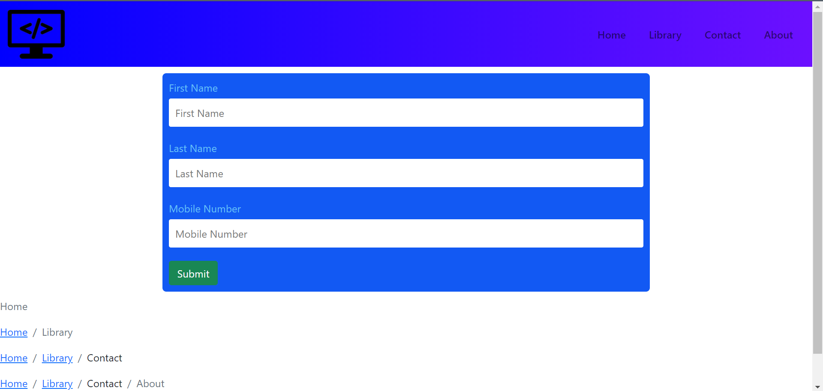 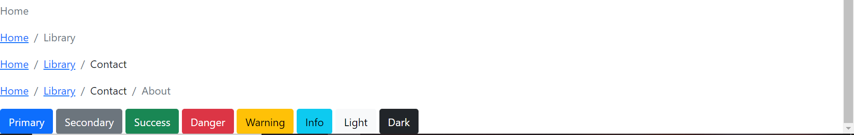

**(LIBRARY PAGE)**

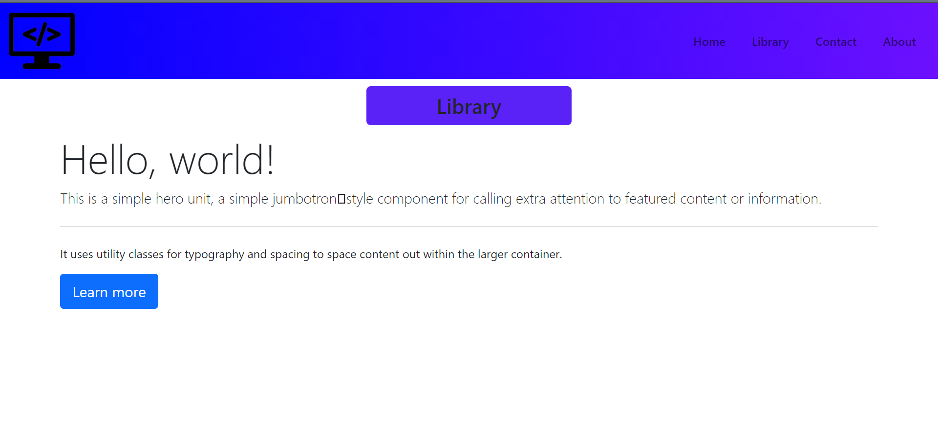

**(CONTACT PAGE)**

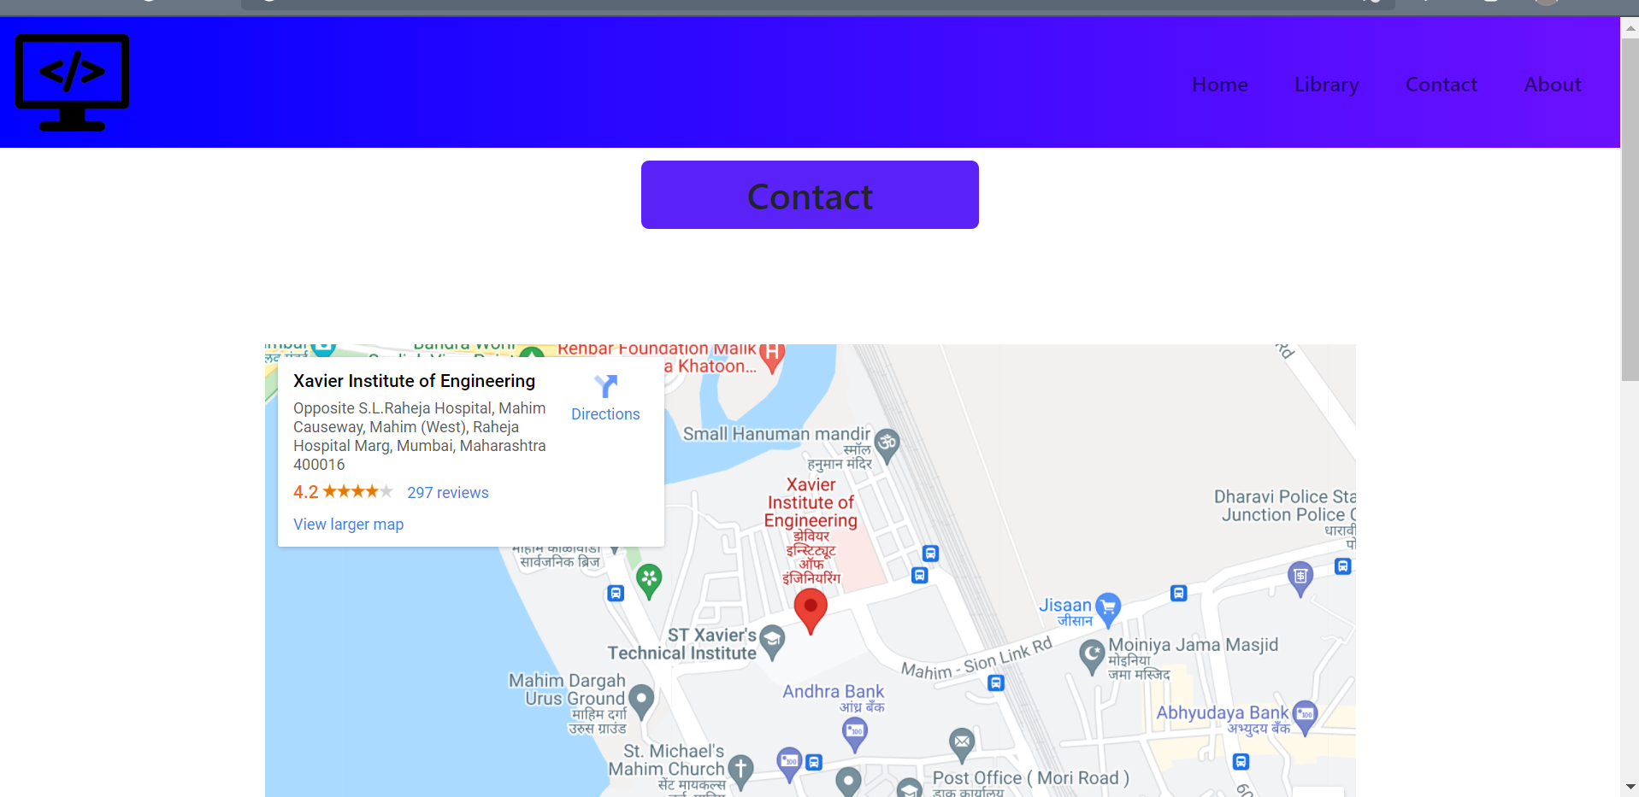 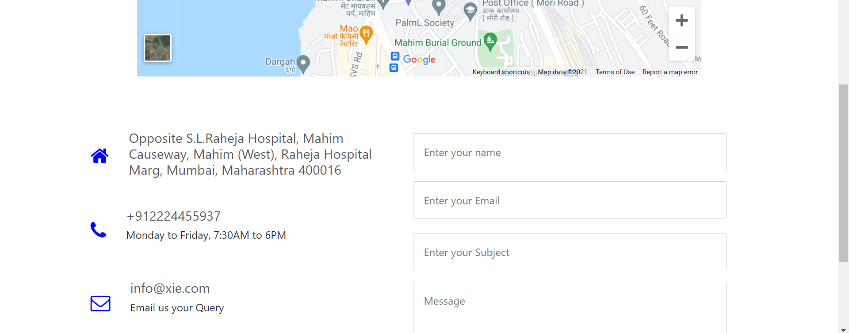 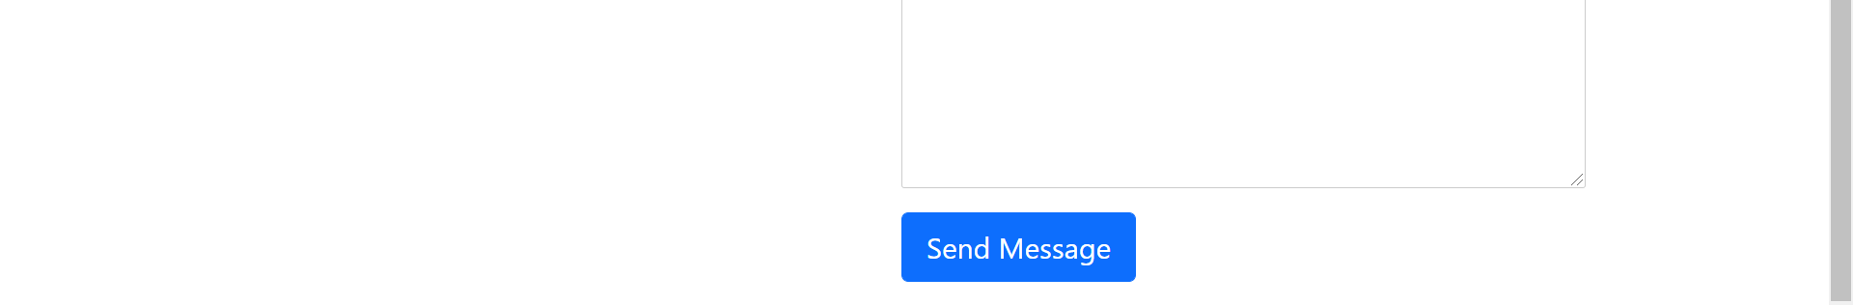

**(ABOUT PAGE)**

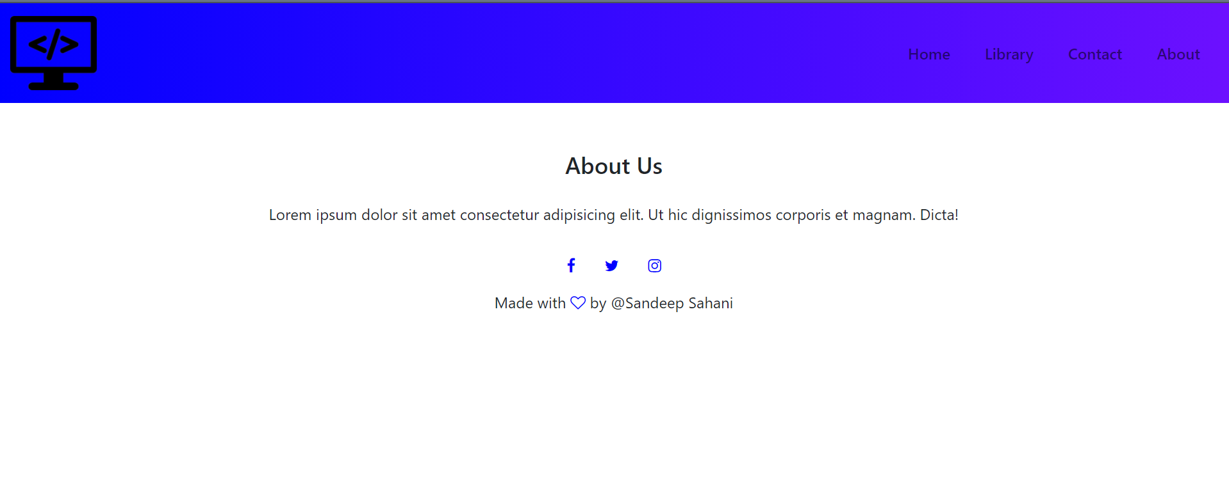

**Conlusion:** In this experiment we have design a website using Bootstrap in that we have used Grid system, Forms, Button, Navbar, Breadcrumb, Jumbotron.